DDCO Unit 3
Q.NO | Questions | Marks
1 | Explain with a neat diagram the basic functional units of a computer. | 5mk
2 | Analyze Big Endian and Little Endian methods of byte addressing with proper example | 5mk
3 | Explain different functional units of computer with block diagram. Mention the functions of following registers i) MAR ii) PC. | 8mk
4 | Represent the decimal values +5, -4 and -7 in the following binary formats:  - Sign and Magnitude ii) 1’s complement iii) 2’s complement. | 6mk
5 | Discuss the parameters that determines the performance of a computer. | 6mk
6 | Register R1 and R2 of a computer contain the decimal values 1200 and  6000. Assume that the computer has 32bit word length. Calculate the  effective address of memory operand in each of the following instructions.  i. Load 10 (R1), R5  ii. Move #2000, R5  iii. Store 30(R1,R2),R5  iv. Add (R2)+, R5  v. Subtract - (R1), R5 | 10mk
7 | Explain how to encode the instructions into 32 bit words with an example | 8mk
8 | What is performance measurement? Explain the overall SPEC rating for the computer in a program suite. | 8mk
9 | A program contain 1000 instructions. Out of that 25% instructions require 4 clock cycles, 40% instructions require 5 clock cycles and remaining requires 3 clock cycles for execution. Find the total time required to execute the program running in a 1 GHz machine. | 4mk
10 | Represent the following decimal values using 5bit binary numbers and subtract them. Check in each case whether overflow occurs.  i) +5 and + 8 ii) +6 and -12 | 6mk
11 | Explain the basic performance equation. | 4mk
12 | Define addressing mode. Explain the following addressing modes with an example for each:  i) indirect addressing mode ii) indexed addressing mode  iii) Relative addressing mode iv) auto decrement addressing mode | 10mk
13 | Illustrate reasons for arithmetic overflow that occur during arithmetic operations also identify the overflow in the following operations:  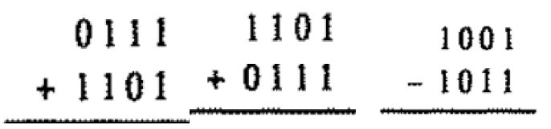 | 7mk
14 | Explain the following with an example:  i) Index addressing mode  ii) PC relative addressing mode  iii) Auto increment addressing mode | 7mk
15 | Explain different formats of encoding machine instruction for different Addressing modes. | 6mk
16 | Explain the connection between the Processor and the Memory with a neat diagram. | 8mk

